**Planning a career in computing**

***Lead in***

1. What are the motivations you had to follow your domain of study?

2. In your opinion, what are the reasons that prevent a person from following CS?

3. What experience, ambitions and areas of expertise and interest within the information technology sector and research (both in the public and private industries) do you have?

4. How do you see the role of the degree credentials in shaping (your) future employment prospects?

***Getting started in research***

***1a. Many students pursue their education in other countries. The table below summarises tertiary (higher education) for science in the US. Make a similar table for your country and then answer the following questions.***

1. Is tertiary education in the US similar to science higher education in your country?
2. If you decided to study abroad, which qualification would be best for you?

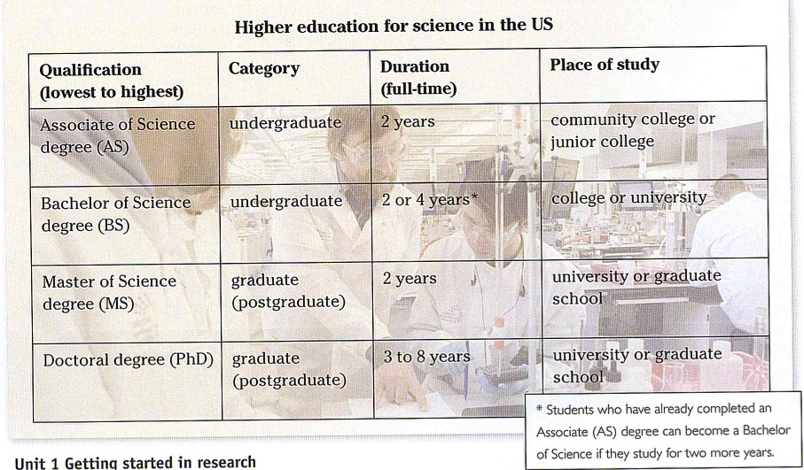

***For further info, also see:***

<https://www.informatics-europe.org/services/informatics-job-platform.html>

<https://jobs.theguardian.com/jobs/it/europe/>

**1a. Eriko is from Japan and she will soon complete a PhD in CS in London. She is discussing the next stage in her career with her supervisor, Susana. Listen to part of their conversation and write the options that interest her and the options that do not.**

**1b. *What are the advantages and disadvantages of working in academia or industry? Brainstorm and then feed back to the class.***

finishing phd – scary

academia definitely interesting communicating theory side of things

industry – more practical

wants to teach, enjoys preparing lectures

no idea with who to work and leave London done everything here

change, move on

doubts they’ll want her

meets Glasglow people

doesn’t mind paperwork

only a bit tempted by money

more important things than money

industry work not for her

***2. You will hear 8 sentences from Eriko and Susana’s conversation. Listen and write down the number of each sentence in the correct column.***

***Talking about…***

|  |
| --- |
| **Likes/Dislikes past experience future (more certain) future (possible)** |
| 1 4 |
| 2 |
| 3 5 |
| 8 |
| 7 6 |
|  |
|  |
|  |
|  |
|  |

***3. Think about your career in Computing and make notes on:***

* your favourite experience in the courses so far;
* past and present STEM experience that could enhance your career in Computing;
* the soft skills vs. the specific technical skills an ideal computer professional (give at least 2 examples for each type of skill);
* your ideal job interview: a code walk-through or a focus on the currency of your skills/employability portfolio;

***Applying for research funding***

***4a. Read the following extract from a website and then answer the questions***:

1. Can an organization apply for the scholarship?
2. Would you be interested in applying for ESRC? Why? Why not?
3. What information might you need to include in your application form?
4. What are the advantages of attracting scientists with ‘future potential for leadership in the field of computing’ to a country?

|  |
| --- |
| **About the project** |
| The ESRC Research Grant Civil Society aims to develop STEM education in Wales by attracting outstanding professionals in the field of computing to continue their academic track in a British university. The fellowship is funded by the University of South Wales as part of the university’s contribution to the new ESRC Research Grant Civil Society – Civic Stratification and Civil Repair awarded to the Wales Institute of Social and Economic Research, Data and Methods (WISERD) Research Centre.  ESRC fellowships are awarded to individual students worldwide with future potential for leadership in their field. Applicants should have a very good BSc (Honours) (First or Upper Second class) degree or a Master degree (with Distinction or Merit) in Computing Science or related disciplines. Successful applicants receive a 4-year grant covering salary, travel and relocation costs. |

***Extension activity: investigating a fellowship***

***Think about how to obtain more information about the fellowship in Exercise 4a. Write an email to the fellowship committee asking your questions.***

For more examples of fellowship adverts, also see:

<https://www.findaphd.com/phds/project/data-analysis-for-digital-entrepreneurship-self-employment-application-ref-sf19-ee-cis-anwar/?p115214>

<https://www.findaphd.com/phds/project/a-decentralized-data-driven-health-monitoring-and-diagnostics-platform-based-on-artificial-intelligence-ai-and-wearable-portable-internet-of-medical-things-iomt-sensors/?p121340>

***4b. Eriko has decided to apply to ESRC and has downloaded an application form. Look at the list of sections on the form (1-10) and match each one to Eriko’s notes on the information she needs to provide (a-j).***

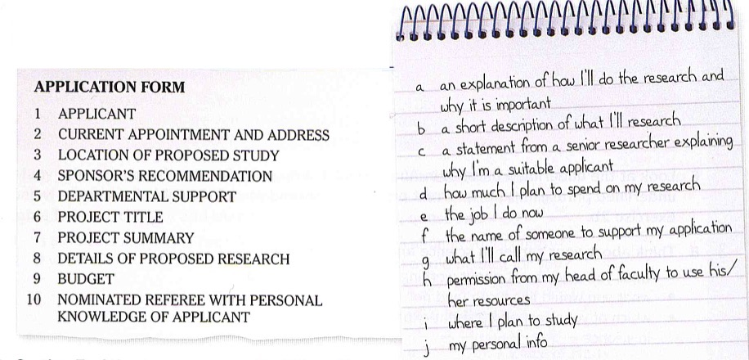

***4c. Section 7 of the of the form asks applicants to write a project summary of their research proposal. Think about a research topic in your area. Summarize the project following the instructions (1-6) below.***

1. State the aims of your research;
2. Identify the area for new work;
3. Explain why your topic/project is worth researching/endorsing;
4. Say what the expected outcomes (concrete goals and deliverables) are;
5. Outline the methodology you will follow;
6. Outline the limitations of your project;

***Extension activity Once you have laid out the draft of your research summary you may consider the following sense-making CRM (Computing Research Methods) framework which describes the cycle of research. Each question (1-4) anchors a quadrant in the process of computing research***

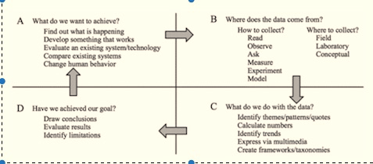

Research project tenses